EXPERIMENT 3 – WATER JUG PROBLEM

AIM
To develop a Python program to solve the Water Jug Problem using the Breadth First Search (BFS) algorithm.

OBJECTIVE
To prove that the BFS algorithm can find a sequence of operations to obtain the required amount of water using two jugs.

ALGORITHM
- Define the capacities of the two water jugs and the target amount.
- Start with both jugs empty and store the initial state.
- Generate all possible states by filling, emptying, or pouring water between the jugs.
- Continue exploring new states until the target amount is obtained.
- Display the sequence of steps that leads to the target solution.

SAMPLE CODE

from collections import deque

def water_jug(jug1, jug2, target):
visited = set()
queue = deque([((0, 0), [])])

while queue:
(a, b), path = queue.popleft()

if (a, b) in visited:
continue

visited.add((a, b))
path = path + [(a, b)]

if a == target or b == target:
return path

next_states = [
(jug1, b), # Fill Jug1
(a, jug2), # Fill Jug2
(0, b), # Empty Jug1
(a, 0), # Empty Jug2
(a - min(a, jug2 - b), b + min(a, jug2 - b)), # Pour Jug1 -> Jug2
(a + min(b, jug1 - a), b - min(b, jug1 - a)) # Pour Jug2 -> Jug1
]

for state in next_states:
if state not in visited:
queue.append((state, path))

return None

jug1 = 4
jug2 = 3
target = 2

solution = water_jug(jug1, jug2, target)

print("Solution Steps:")
for step in solution:
print(step)

FLOW CHART
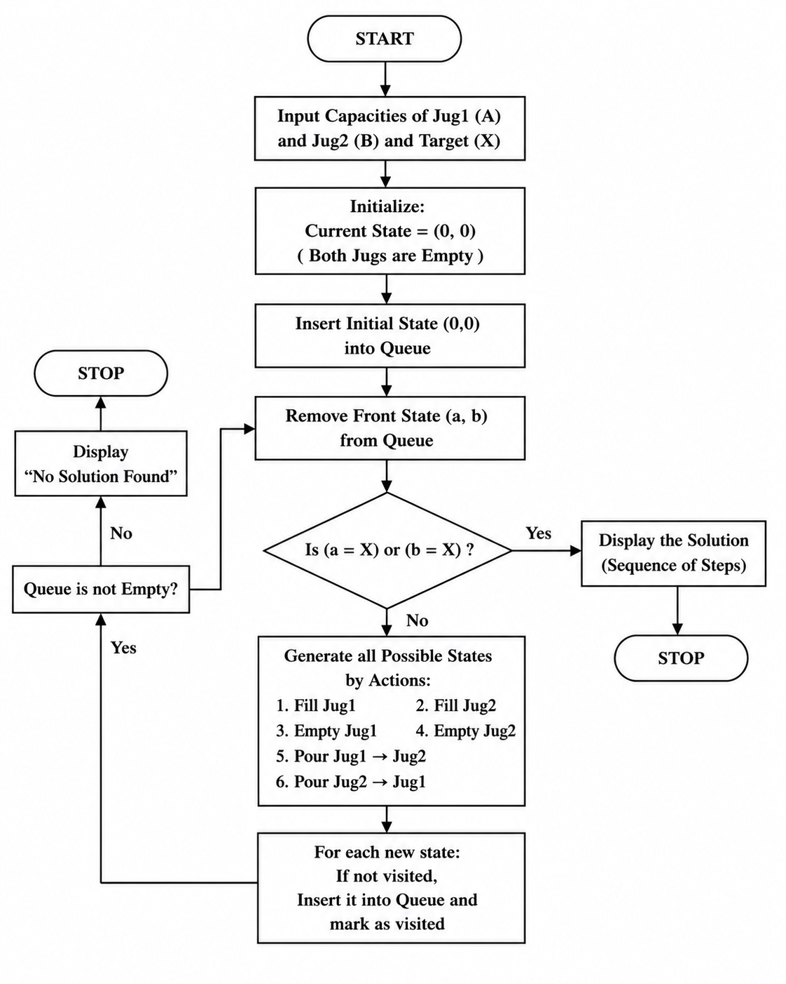
OUTPUT
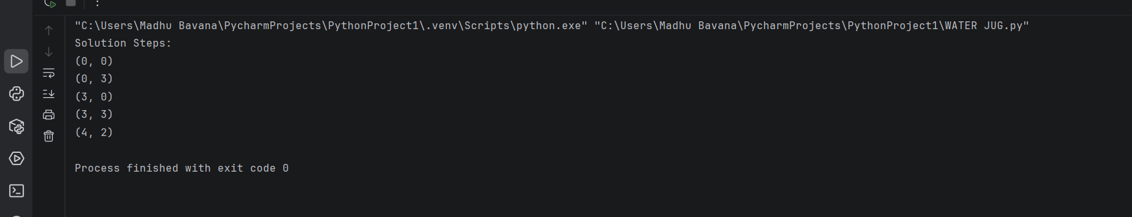

RESULT
The Python program was executed successfully. The Breadth First Search (BFS) algorithm found the sequence of operations required to obtain the target quantity of water using the two jugs.

